**2. PASSPORT MANAGEMENT SYSTEM**

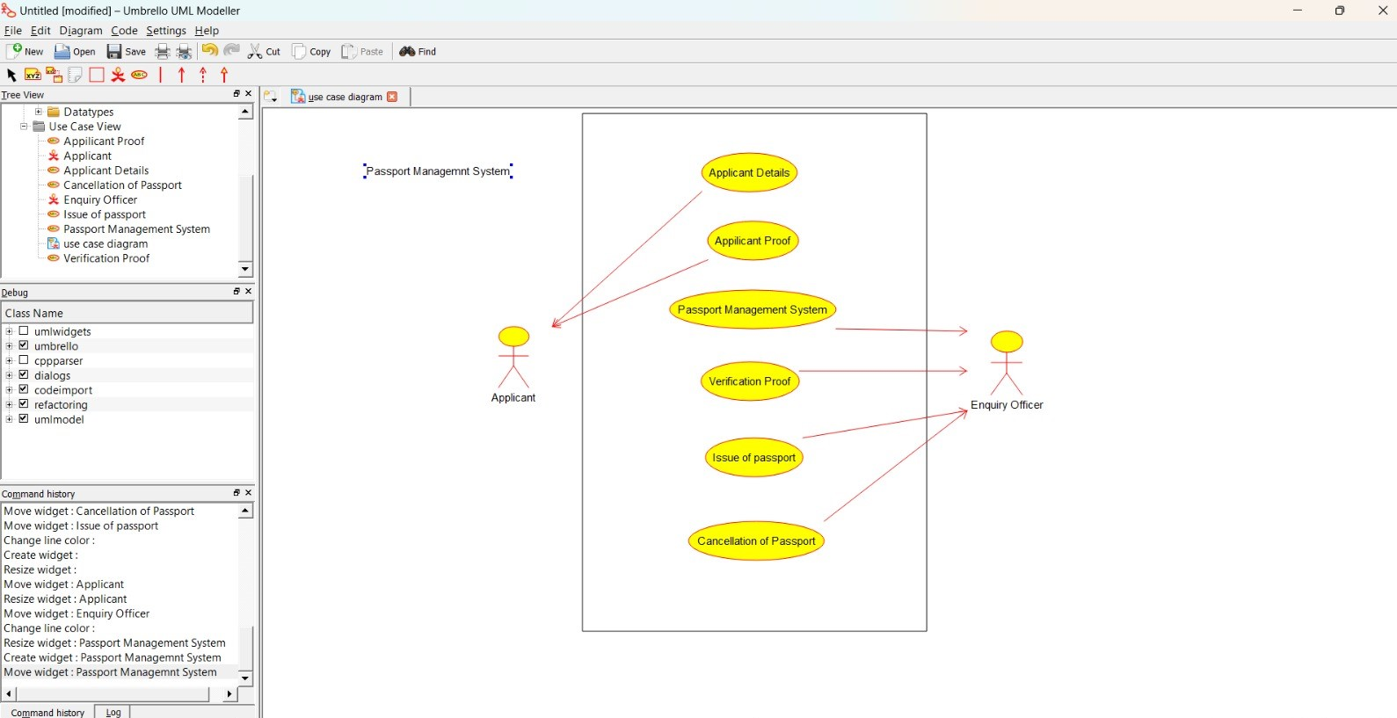

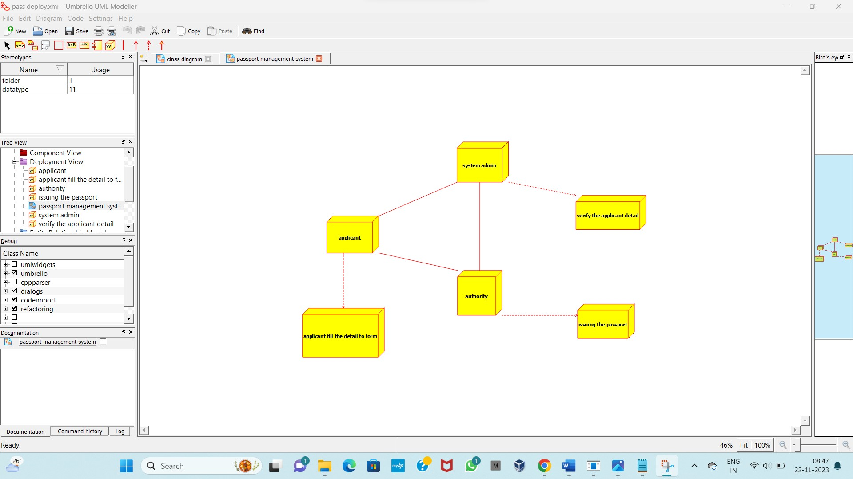

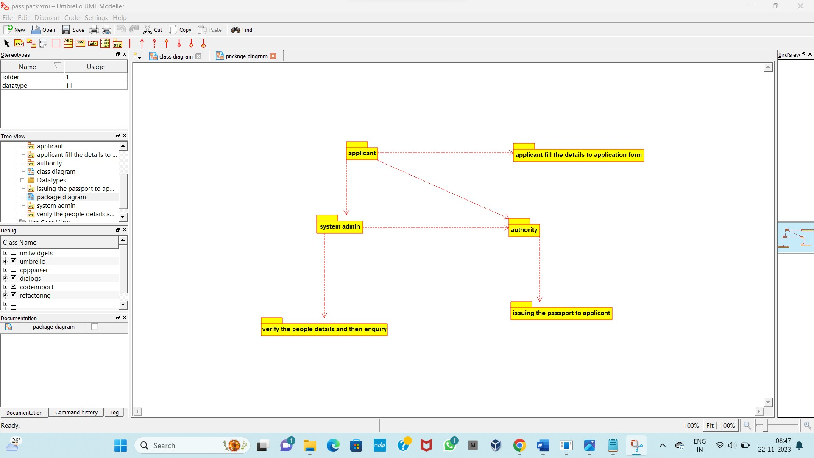

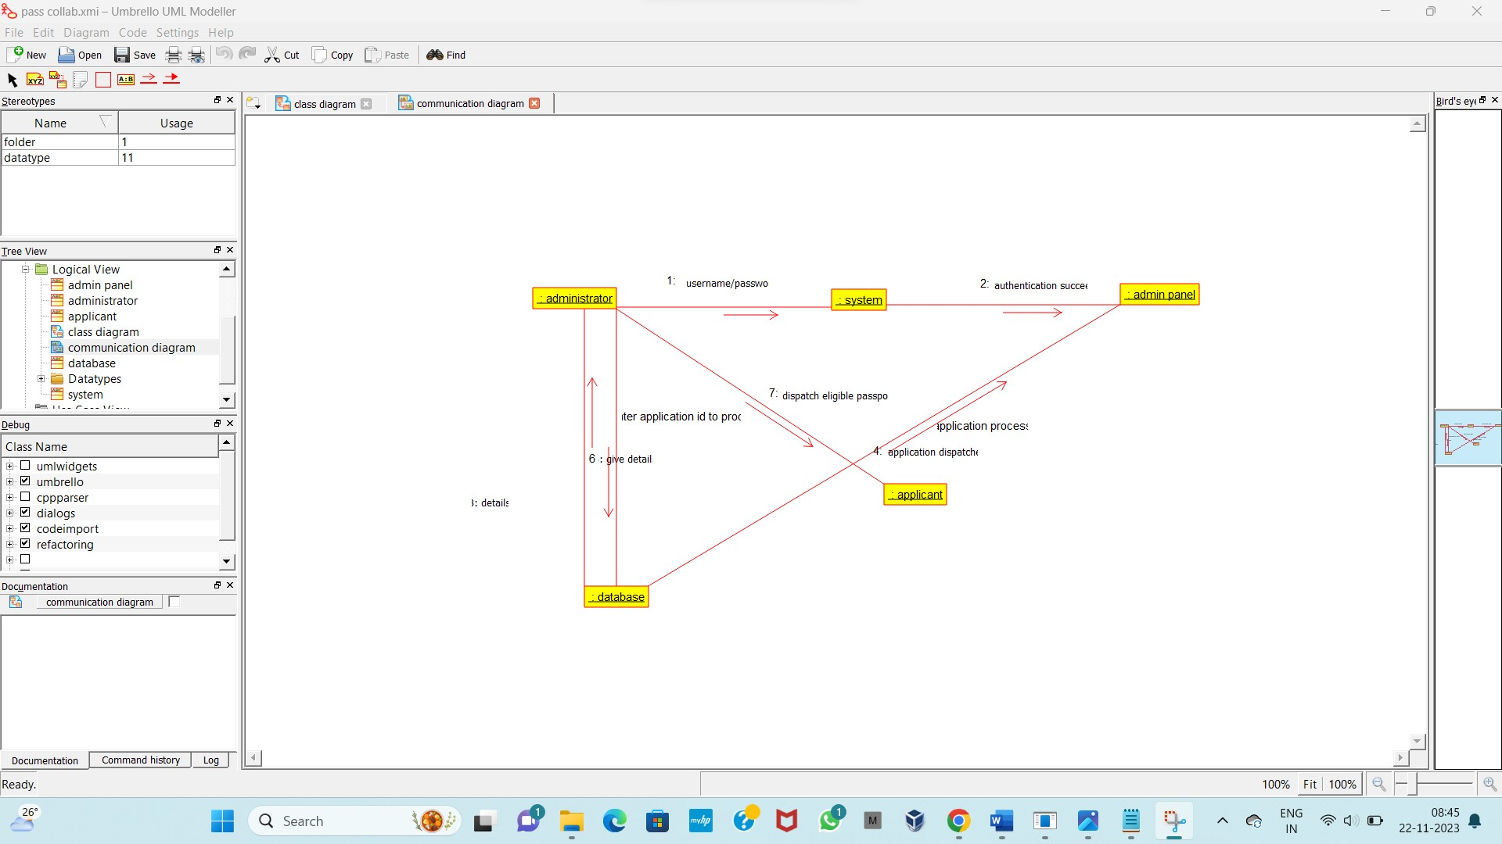

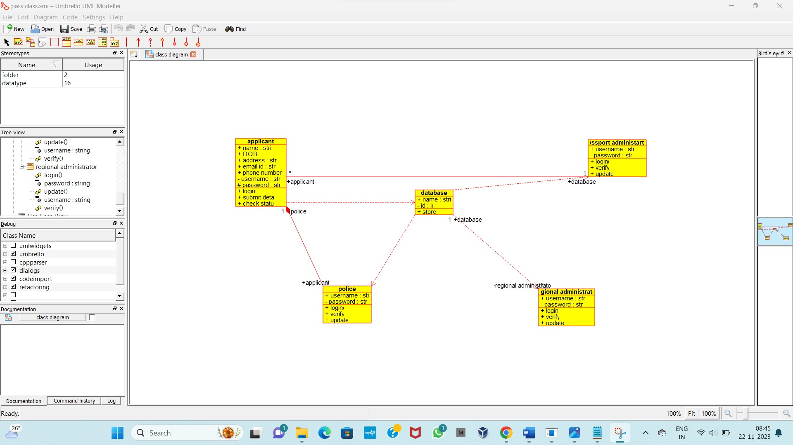

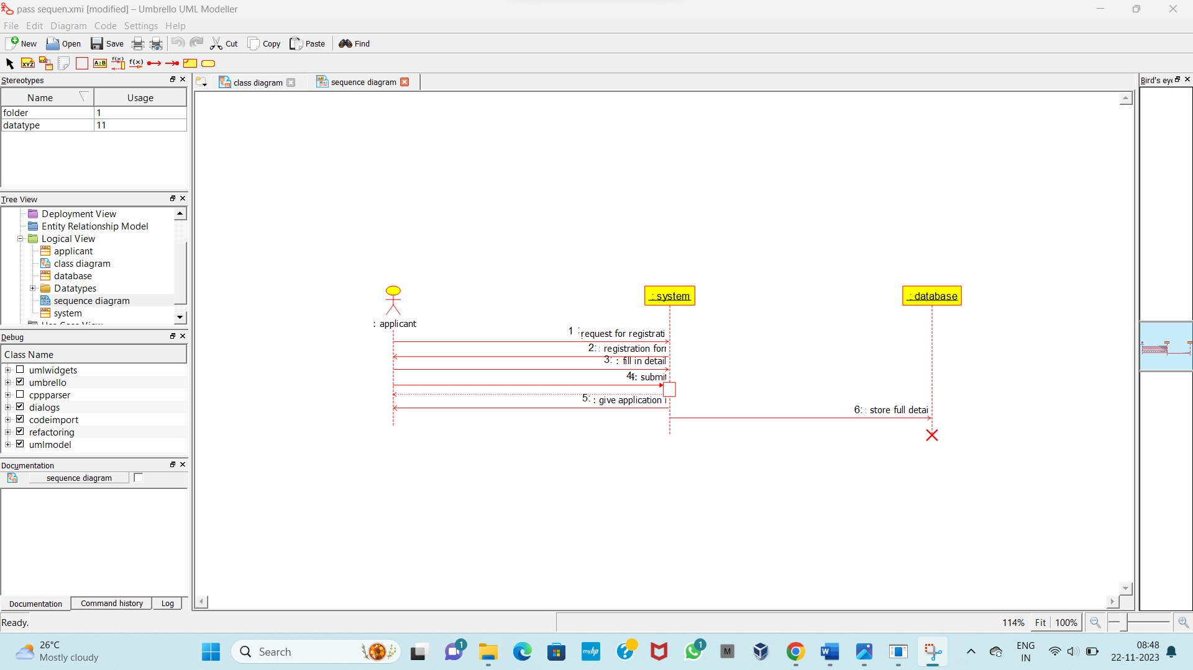

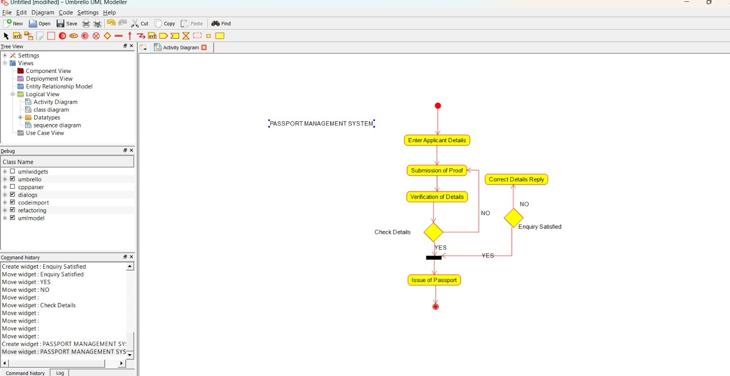

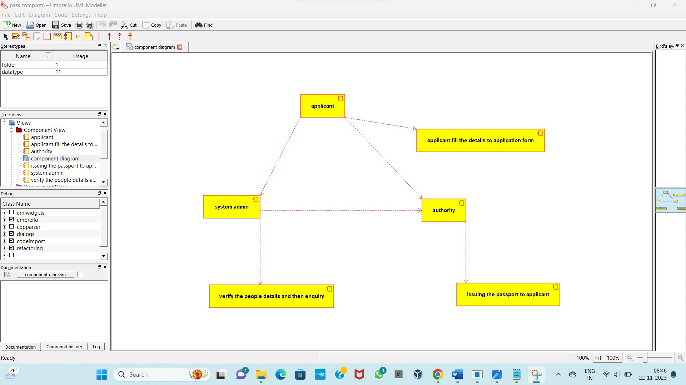

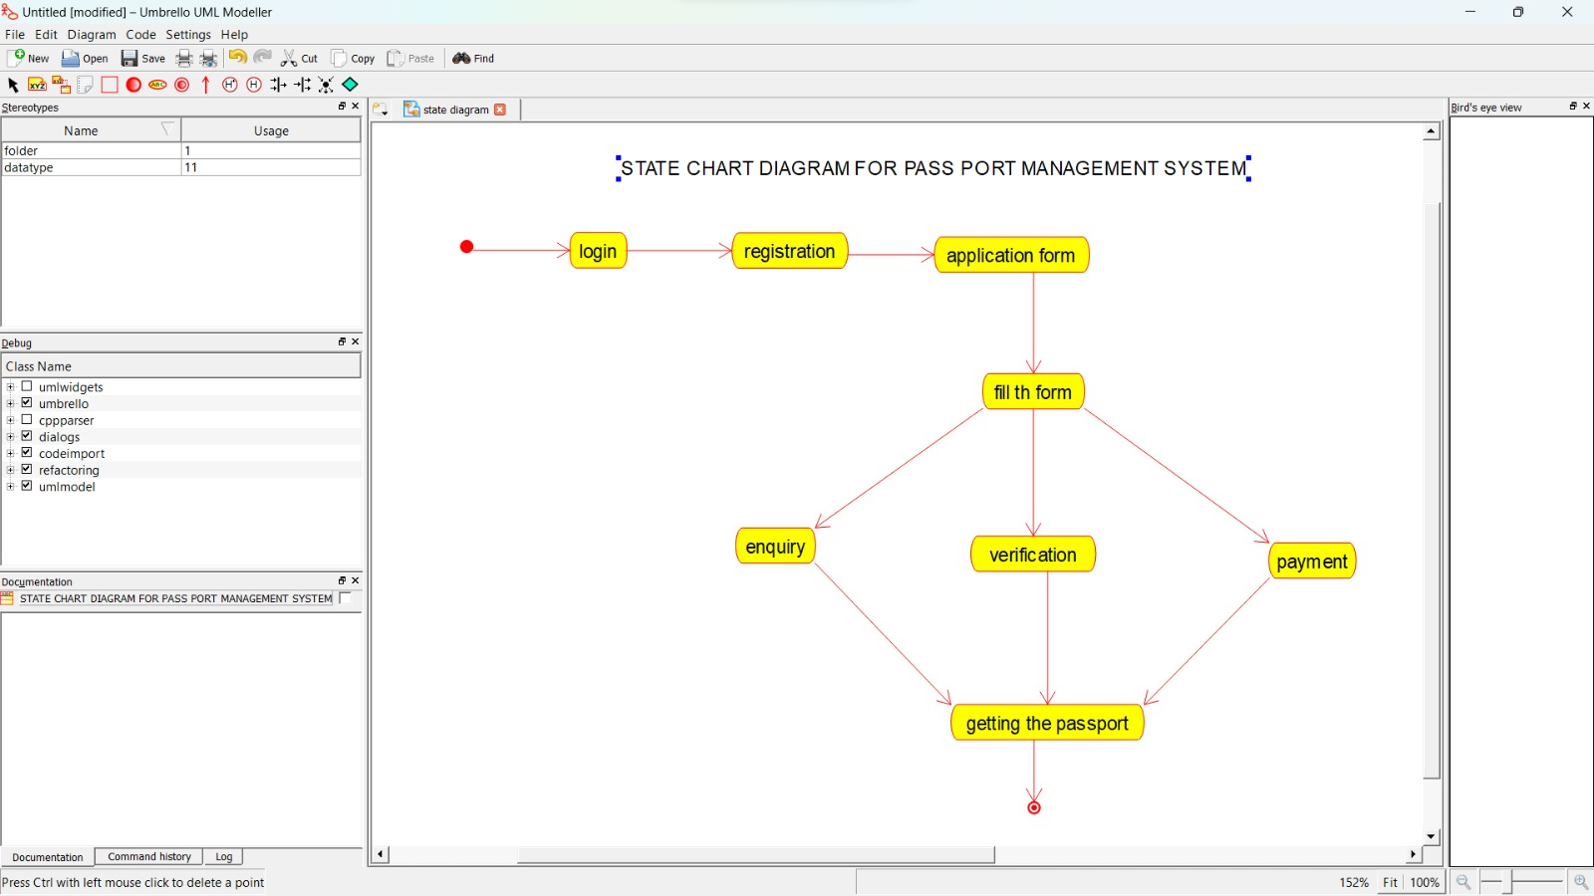

**CODE SKELETON:**

**# coding=System**

**from database import \***

**from passport_administartor import \***

**from police import \***

**class applicant(object):**

**"""**

**:version:**

**:author:**

**"""**

**""" ATTRIBUTES**

**name (public)**

**DOB (public)**

**address (public)**

**email_id (public)**

**phone_number (public)**

**username (private)**

**password (protected)**

**"""**

**def login(self):**

**"""**

**@return :**

**@author**

**"""**

**pass**

**def submit_detail(self):**

**"""**

**@return :**

**@author**

**"""**

**pass**

**def check_status(self):**

**"""**

**@return :**

**@author**

**"""**

**pass**